# 

CAR RENTAL DATABASE SYSTEM

Database Project

**Deliverable 3**

**Submitted by**

|  |  |
| --- | --- |
| **Member Name** | **Registration Number** |
| Farah Tanveer | (BCSF24M016) |
| Ayesha Bint E Younas | (BCSF24M032) |
| Gulshan Mushtaq | (BCSF24M046) |
| Hafsa Kokab | (BCSF24M051) |

**Submitted To**

Dr. Irfana Bibi

# 

# SEQUENCES

# Vehicle sequence:

CREATE SEQUENCE Seq_Vehicle

START WITH 1

INCREMENT BY 1;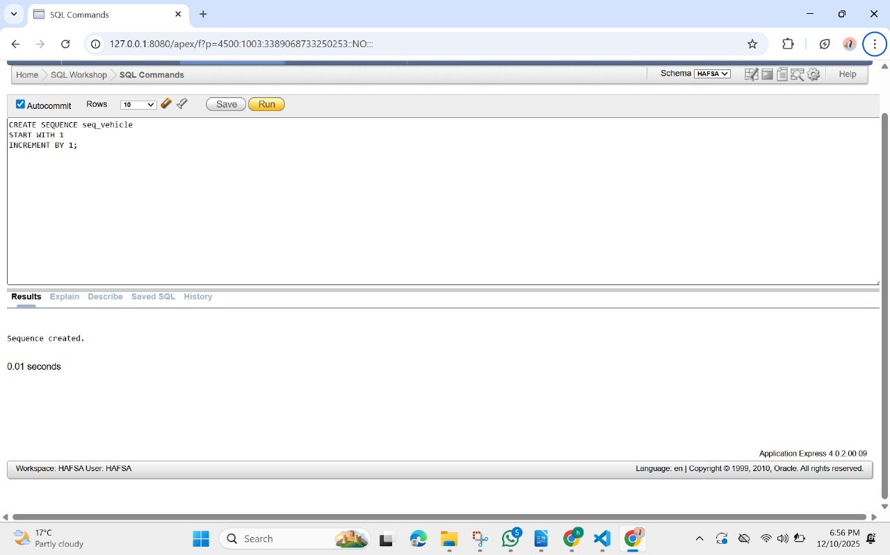

# Company Sequence:

Create sequence SEQ_COMPANY

Start with 1

Increment by 1;

# 

# Staff Sequence:

Create sequence seq_staff

Start with 1

Increment by 1;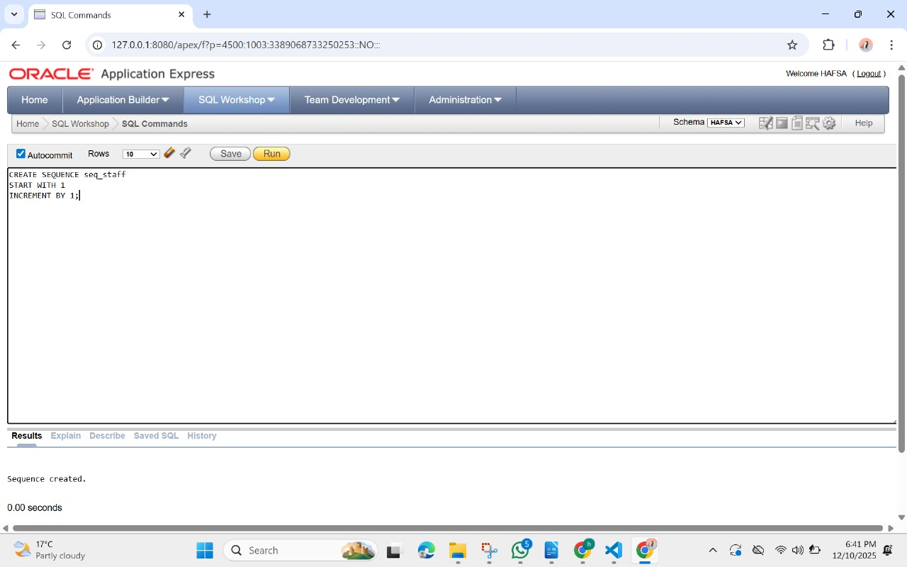

# Role Sequence:

Create sequence seq_role

Start with 1

Increment by 1;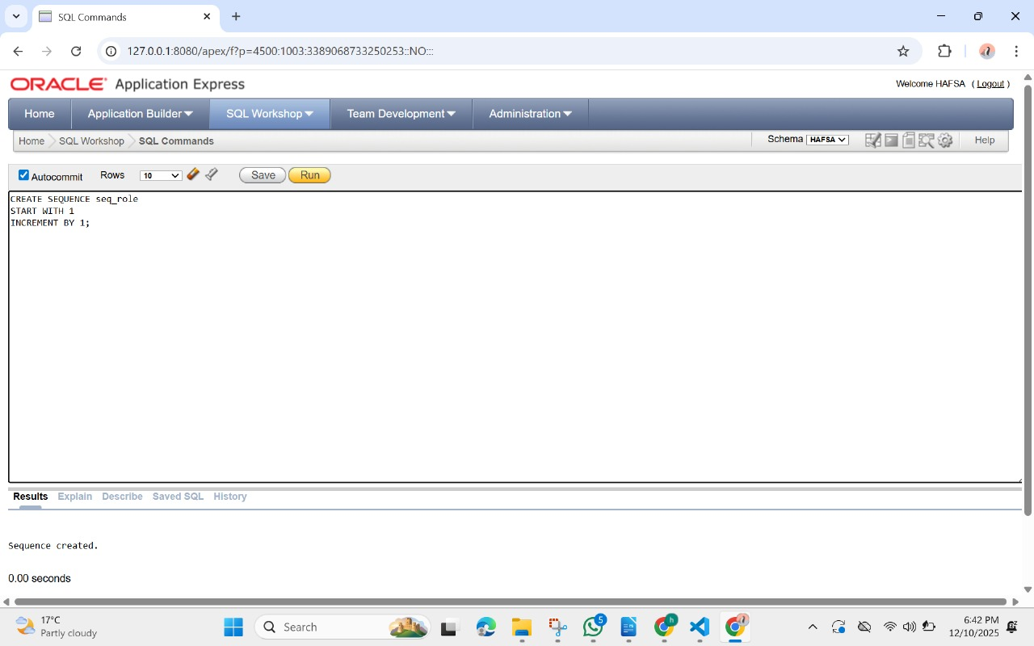Customer Sequence:

Create sequence seq_customer

Start with 1

Increment by 1;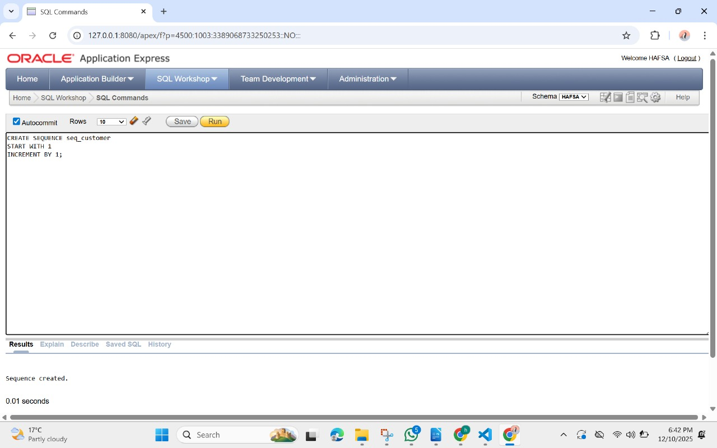

# Reservation Sequence:

CREATE SEQUENCE seq_reservation

START WITH 1

INCREMENT BY 1;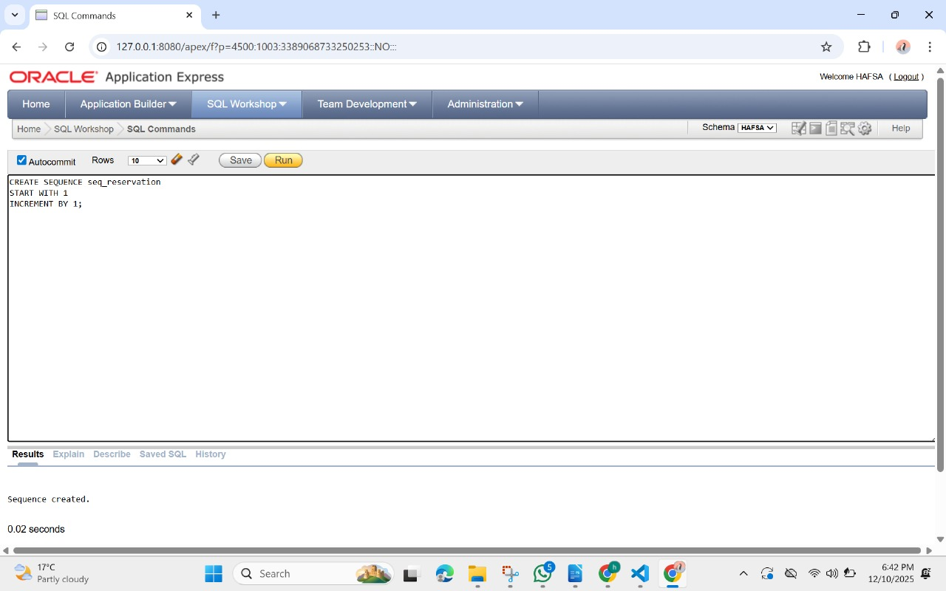

Payment Sequence:  
create sequence SEQ_PAYMENT  
start with 1  
increment by 1;

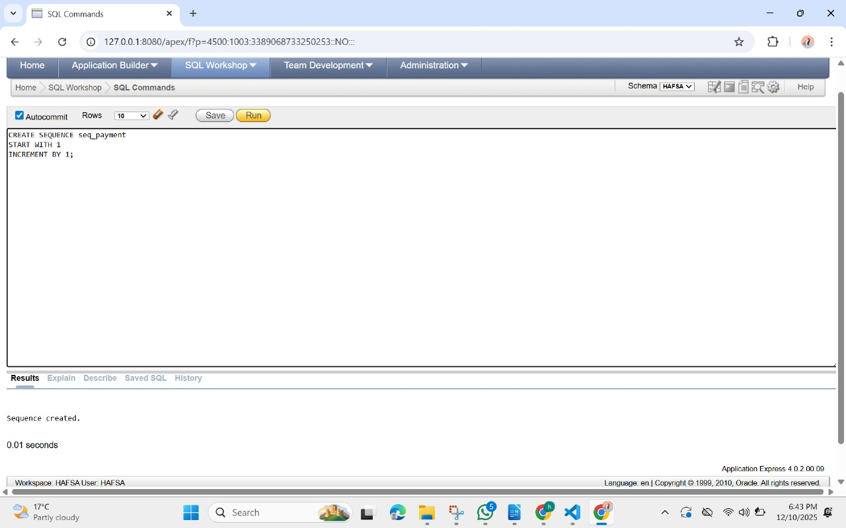Maintenance Sequence:  
create sequence SEQ_MAINTENANCE  
start with 1  
increment by 1;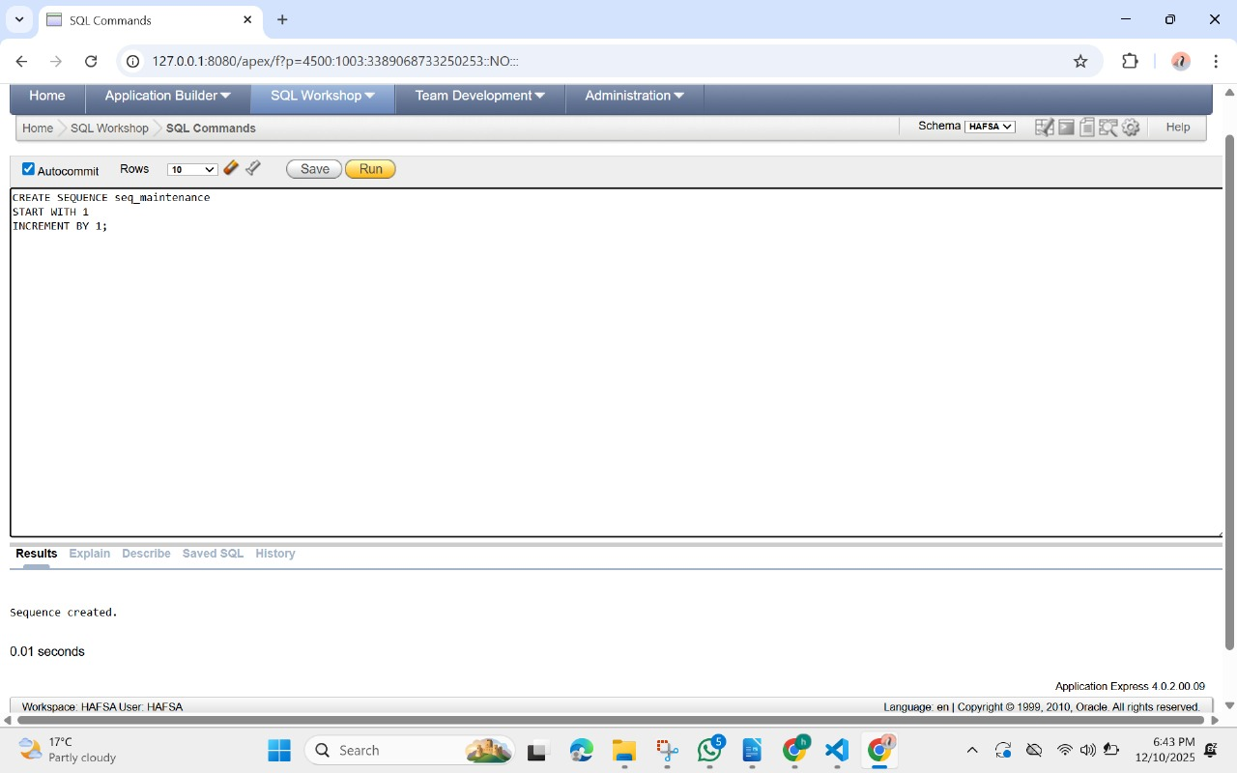

# Damage report Sequence:

Create sequence seq_damage

Start with 1

Increment by 1;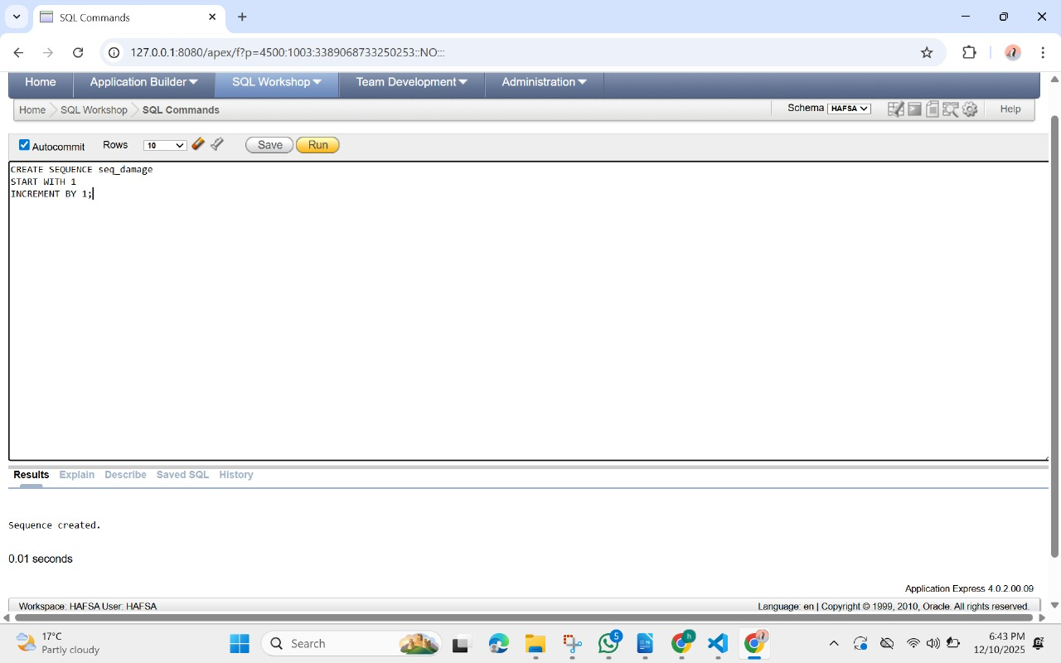

# STORED PROCEDURES

## Add_Reservation_Safely

CREATE OR REPLACE PROCEDURE Add_Reservation_Safely(

p_id NUMBER,

p_vehicle NUMBER,

p_customer NUMBER,

p_staff NUMBER,

p_driver_required CHAR,

p_start DATE,

p_end DATE,

p_rate NUMBER

)

AS

v_vehicle_status VARCHAR2(20);

v_blacklist CHAR(1);

BEGIN

-- Check vehicle availability

SELECT Status INTO v_vehicle_status FROM Vehicle WHERE ID = p_vehicle;

IF v_vehicle_status <> 'Active' THEN

RAISE_APPLICATION_ERROR(-20010, 'Vehicle is not available for reservation');

END IF;

-- Check if customer is blacklisted

SELECT BlackListStatus INTO v_blacklist FROM Customer WHERE ID = p_customer;

IF v_blacklist = 'Y' THEN

RAISE_APPLICATION_ERROR(-20011, 'Blacklisted customers cannot make reservations');

END IF;

-- Insert reservation

INSERT INTO Reservation (ID, Vehicle_id, Customer_id, Staff_id, DriverRequired,

Rent_StartDate, Rent_EndDate, RateNoBooking,

PriceBasis, Status, PaymentStatus)

VALUES (p_id, p_vehicle, p_customer, p_staff, p_driver_required,

p_start, p_end, p_rate, 'Daily', 'Reserved', 'UNPAID');

END;

/

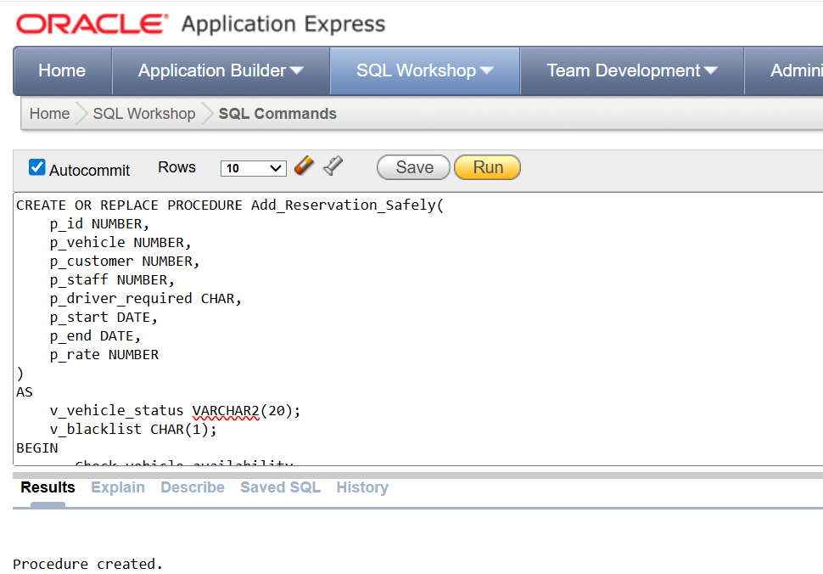

Cancellation of reservation

CREATE OR REPLACE PROCEDURE Cancel_Reservation

(

p_reservation_id NUMBER

)

AS

v_vehicle NUMBER;

BEGIN

-- 1. Get Vehicle ID of this reservation

SELECT Vehicle_id

INTO v_vehicle

FROM Reservation

WHERE ID = p_reservation_id;

-- 2. Cancel the reservation

UPDATE Reservation

SET Status = 'Canceled',

PaymentStatus = 'UNPAID'

WHERE ID = p_reservation_id;

-- 3. Mark vehicle as Active (available again)

UPDATE Vehicle

SET Status = 'Active'

WHERE ID = v_vehicle;

COMMIT;

EXCEPTION

WHEN NO_DATA_FOUND THEN

RAISE_APPLICATION_ERROR(-20061, 'Cancel failed: Reservation ID not found.');

WHEN OTHERS THEN

RAISE_APPLICATION_ERROR(-20062, 'Cancellation error: ' || SQLERRM);

END;

/

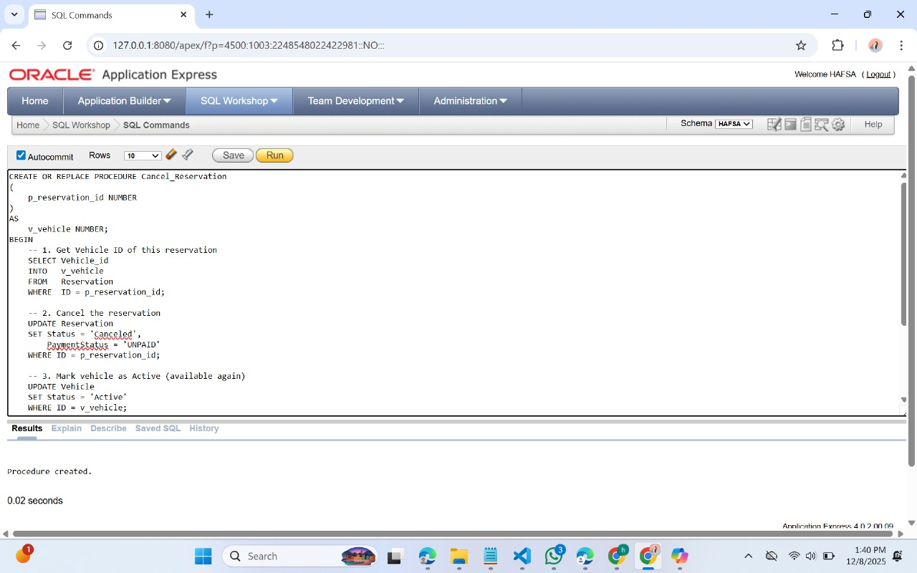

TRIGGERS

Update Vehicle Status After Reservation

CREATE OR REPLACE TRIGGER trg_vehicle_status_update

AFTER INSERT OR UPDATE ON Reservation

FOR EACH ROW

BEGIN

IF :NEW.Status = 'Reserved' THEN

UPDATE Vehicle

SET Status = 'Reserved'

WHERE ID = :NEW.Vehicle_id;

ELSIF :NEW.Status = 'Canceled' THEN

UPDATE Vehicle

SET Status = 'Active'

WHERE ID = :NEW.Vehicle_id;

END IF;

END;

/

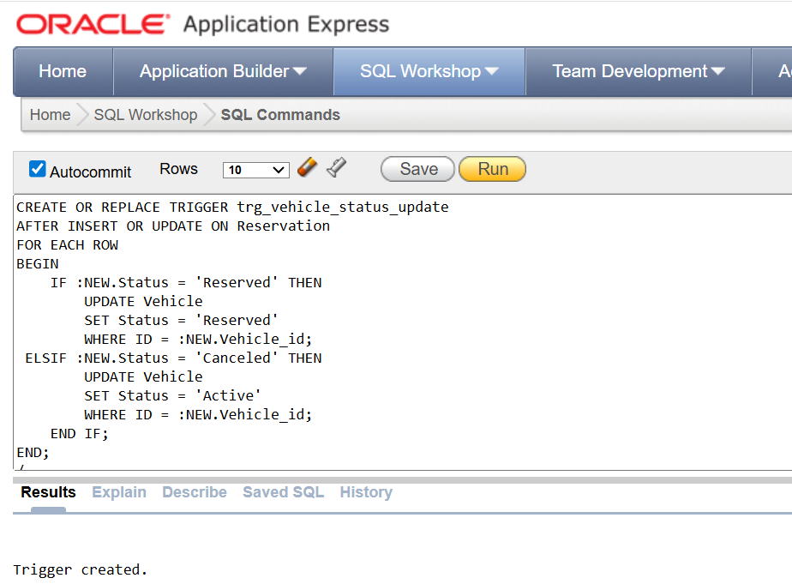

Auto-Creation of Maintenance on High Damage Report

CREATE OR REPLACE TRIGGER trg_auto_maintenance

AFTER INSERT ON Damage_Report

FOR EACH ROW

WHEN (NEW.SEVERITYLEVEL = 'HIGH')

BEGIN

INSERT INTO Maintenance (ID, Vehicle_id, Staff_id, MaintenanceDate, Description, Cost) VALUES (

Maintenance_seq.NEXTVAL,

:NEW.Vehicle_id,

2,

SYSDATE,

'Maintenance created from HIGH damage report',

:NEW.EstimatedCost

);

END;

/

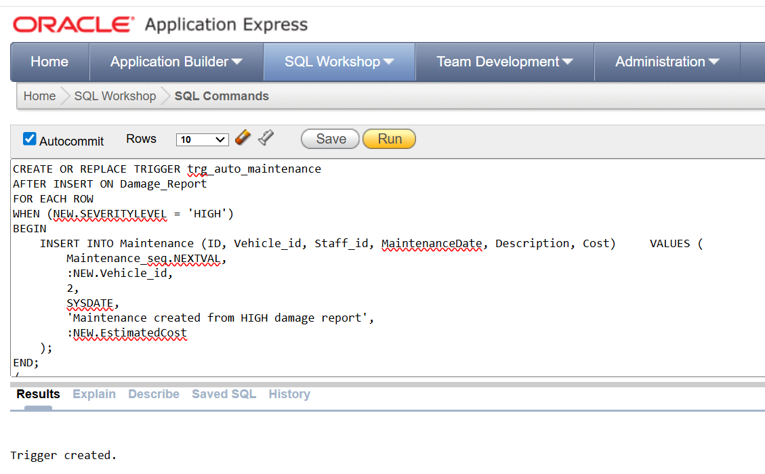

Prevent overlapping reservations for same vehicle

CREATE OR REPLACE TRIGGER trg_no_overlap_res

BEFORE INSERT OR UPDATE ON Reservation

FOR EACH ROW

DECLARE

v_count NUMBER;

BEGIN

SELECT COUNT(*)

INTO v_count

FROM Reservation

WHERE Vehicle_id = :NEW.Vehicle_id

AND Status IN ('Reserved', 'Confirmed')

AND (

:NEW.Rent_StartDate BETWEEN Rent_StartDate AND Rent_EndDate

OR :NEW.Rent_EndDate BETWEEN Rent_StartDate AND Rent_EndDate

OR ( :NEW.Rent_StartDate <= Rent_StartDate AND :NEW.Rent_EndDate >= Rent_EndDate )

);

IF v_count > 0 THEN

RAISE_APPLICATION_ERROR(-20002,

'This vehicle already has an active reservation in this date range.');

END IF;

END;

/

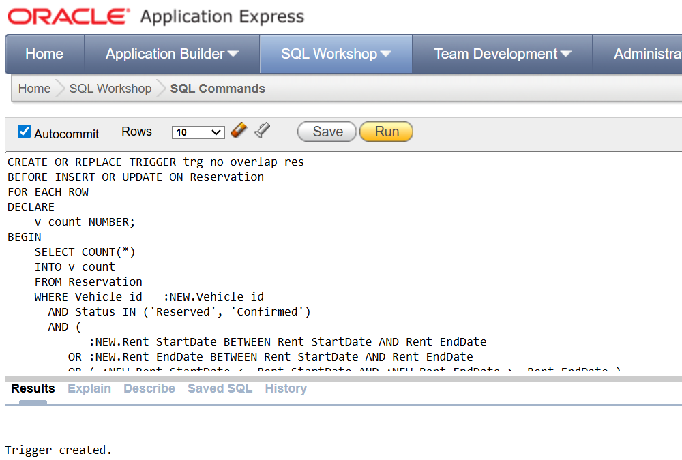

No reservations can be made for under maintenance vehicle

CREATE OR REPLACE TRIGGER trg_res_veh_main

BEFORE INSERT OR UPDATE ON Reservation

FOR EACH ROW

DECLARE

v_status VARCHAR2(20);

BEGIN

SELECT Status INTO v_status

FROM Vehicle

WHERE ID = :NEW.Vehicle_id;

IF v_status = 'MAINTENANCE' THEN

RAISE_APPLICATION_ERROR(

-30004,

'Vehicle under maintenance cannot be reserved.'

);

END IF;

END;

/

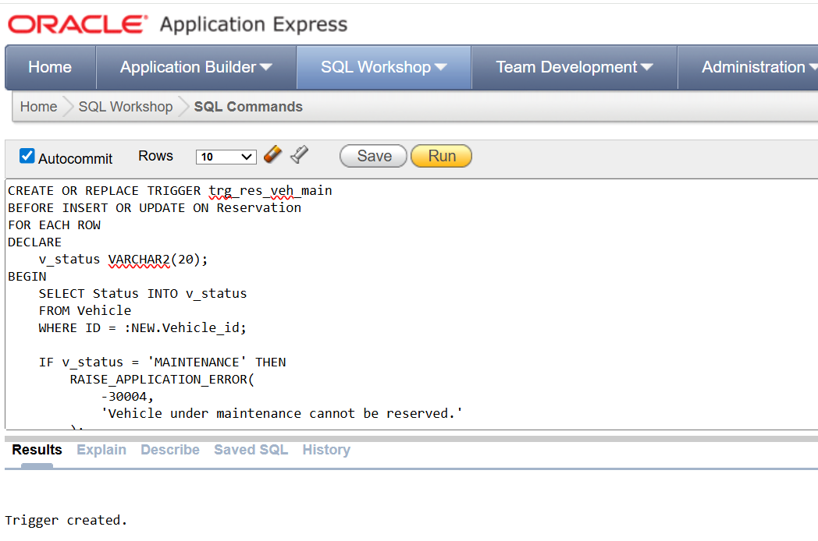

No maintenance can be made for reserved vehicle

CREATE OR REPLACE TRIGGER trg_no_maintenance_if_reserved

BEFORE INSERT ON Maintenance

FOR EACH ROW

DECLARE

v_status VARCHAR2(20);

BEGIN

SELECT Status INTO v_status

FROM Vehicle

WHERE ID = :NEW.Vehicle_id;

IF v_status IN ('Reserved', 'Rented') THEN

RAISE_APPLICATION_ERROR(

-20003,

'Cannot insert maintenance: Vehicle is Reserved or Rented.'

);

END IF;

END;

/

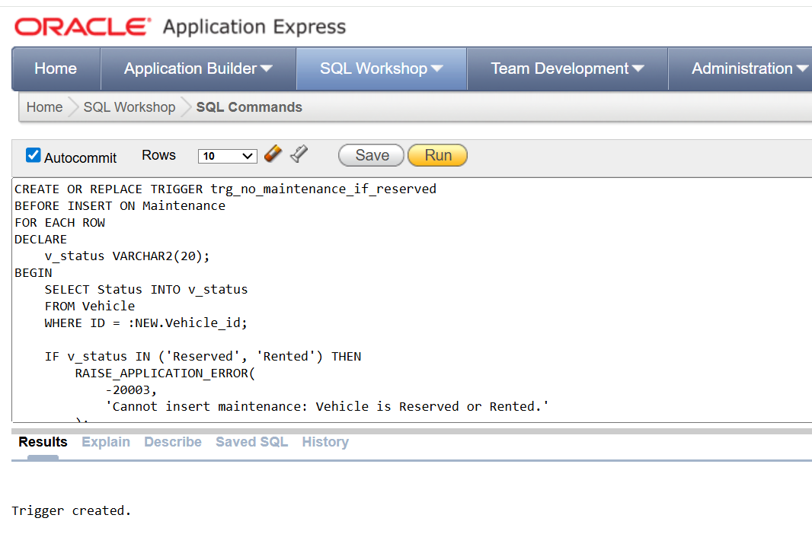

Enforce staff role for maintenance (only mechanics and other staff[cleaner] allowed

CREATE OR REPLACE TRIGGER trg_mech_req_main

BEFORE INSERT ON Maintenance

FOR EACH ROW

DECLARE

v_role VARCHAR2(30);

BEGIN

SELECT r.Name

INTO v_role

FROM Staff s

JOIN Role r ON s.Role_id = r.ID

WHERE s.ID = :NEW.Staff_id;

IF v_role <> 'MECHANIC' AND v_role <> 'Other Staff' THEN

RAISE_APPLICATION_ERROR(

-20004,

'Only mechanics (Other Staff role) can perform maintenance.'

);

END IF;

END;

/

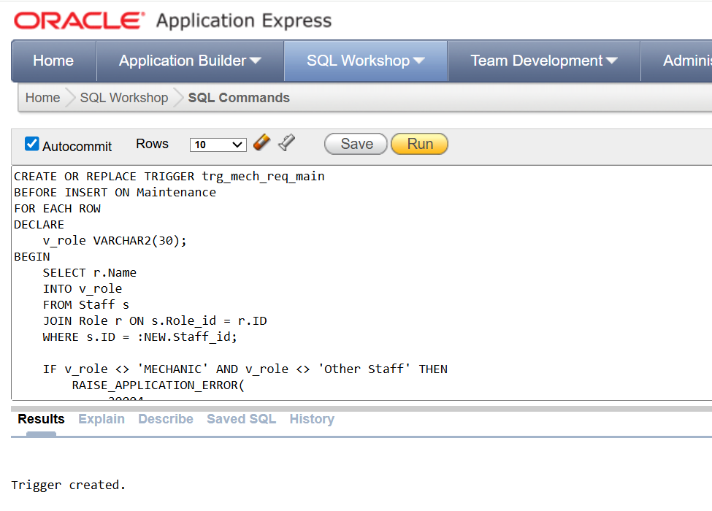

Prevent blacklisted customer from making reservations

CREATE OR REPLACE TRIGGER trg_blklist_res

BEFORE INSERT ON Reservation

FOR EACH ROW

DECLARE

v_black CHAR(1);

BEGIN

SELECT BlackListStatus

INTO v_black

FROM Customer

WHERE ID = :NEW.Customer_id;

IF v_black = 'Y' THEN

RAISE_APPLICATION_ERROR(

-20001,

'This customer is blacklisted and cannot make a reservation.'

);

END IF;

END;

/

## CALCULATING PAYMENT FOR RESERVATION CREATE OR REPLACE TRIGGER trg_calculate_payment

BEFORE INSERT ON Payment

FOR EACH ROW

DECLARE

v_rate NUMBER;

v_start DATE;

v_end DATE;

v_days NUMBER;

v_amount NUMBER;

v_customer NUMBER;

BEGIN

-- Fetch Reservation Data

SELECT r.RateNoBooking,

r.Rent_StartDate,

r.Rent_EndDate,

r.Customer_id

INTO v_rate, v_start, v_end, v_customer

FROM Reservation r

WHERE r.ID = :NEW.Reservation_id;

-- Billing Days Calculation

v_days := CASE

WHEN v_end = v_start THEN 1

ELSE CEIL(v_end - v_start)

END;

-- Payment amount calculation

v_amount := v_rate * v_days;

-- Override user input with correct values

:NEW.Amount := v_amount;

:NEW.Customer_id := v_customer;

:NEW.PaymentDate := SYSDATE;

EXCEPTION

WHEN NO_DATA_FOUND THEN

RAISE_APPLICATION_ERROR(-20051,

'Reservation not found OR RateNoBooking is NULL.');

WHEN OTHERS THEN

RAISE_APPLICATION_ERROR(-20052,

'Payment calculation failed: ' || SQLERRM);

END;

/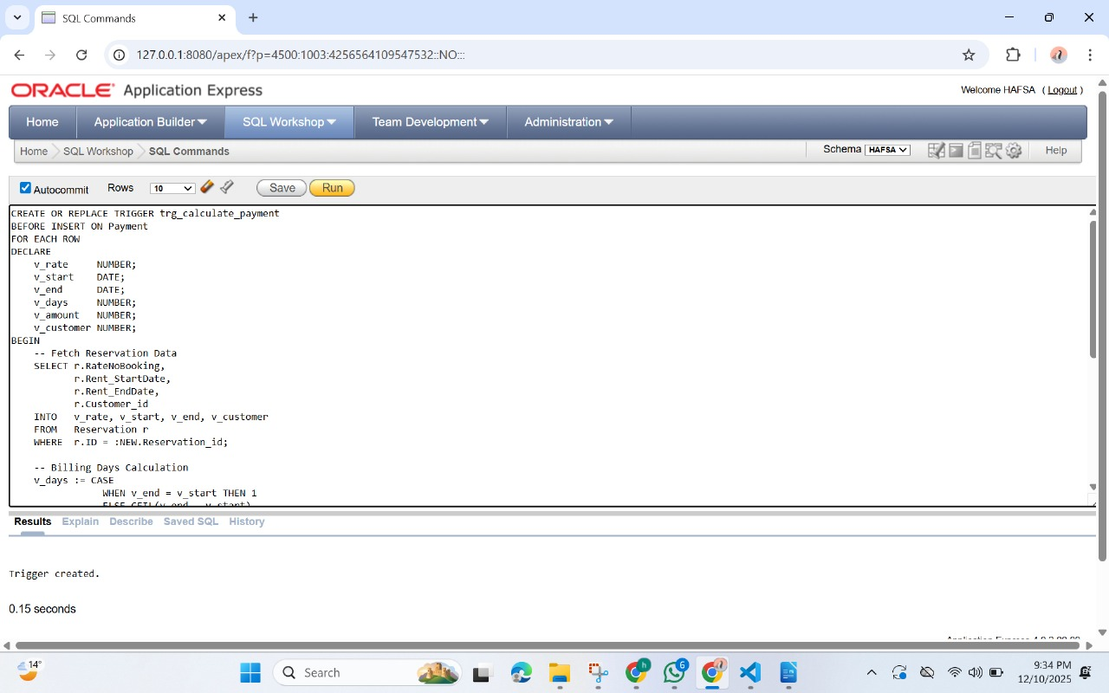

# INDEXES

Reservation Customer Index

CREATE INDEX idx_reservation_customer

ON Reservation(Customer_id); 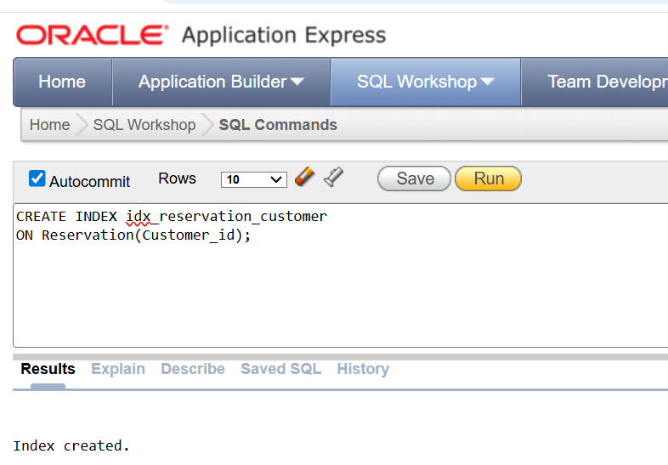

Creating an index on maintenance table

CREATE INDEX idx_maintenance_vehicle  
ON Maintenance (Vehicle_id);

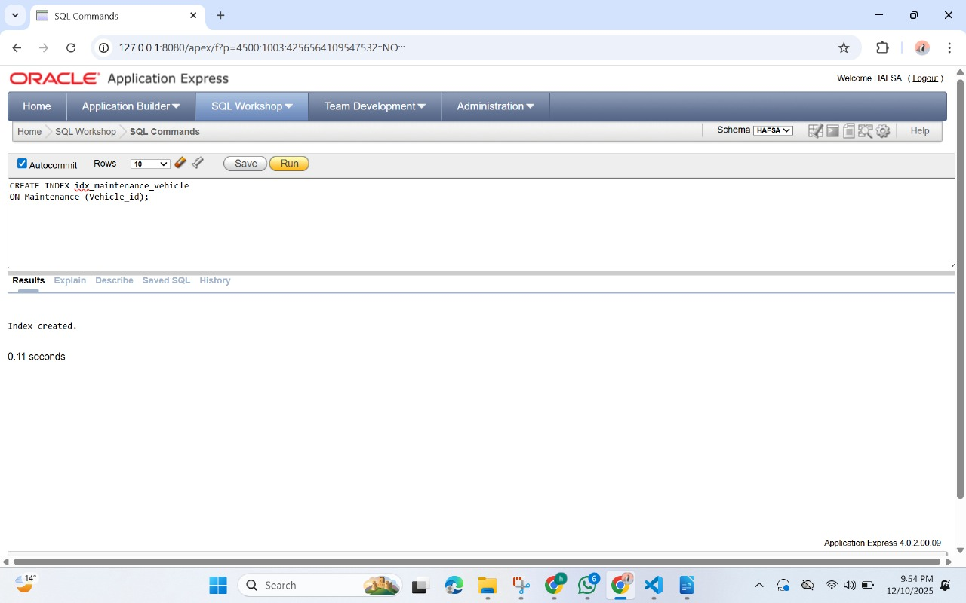

# VIEWS

View: Customer Summary

CREATE OR REPLACE VIEW vw_customer_summary AS

SELECT

c.ID AS CustomerID,

c.FirstName || ' ' || c.LastName AS CustomerName,

c.PhoneNumber,

c.Email,

c.Address,

c.BlackListStatus,

r.ID AS ReservationID,

r.Rent_StartDate,

r.Rent_EndDate,

r.Status AS ReservationStatus,

p.Amount AS LastPaymentAmount,

p.PaymentDate AS LastPaymentDate

FROM Customer c

LEFT JOIN Reservation r

ON c.ID = r.Customer_id

LEFT JOIN Payment p

ON r.ID = p.Reservation_id;

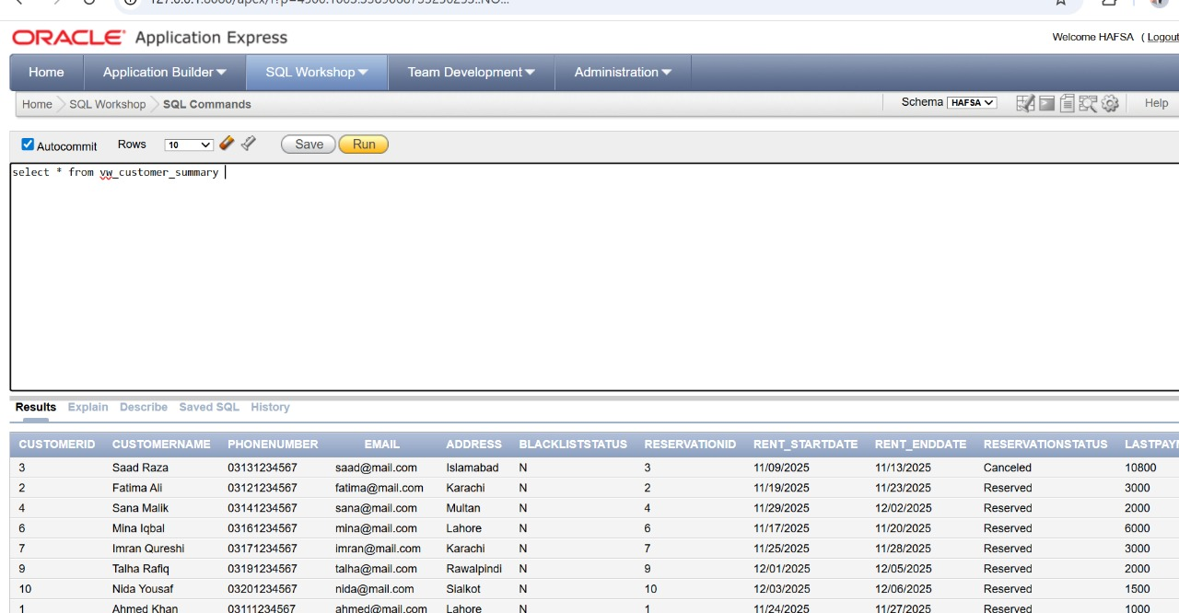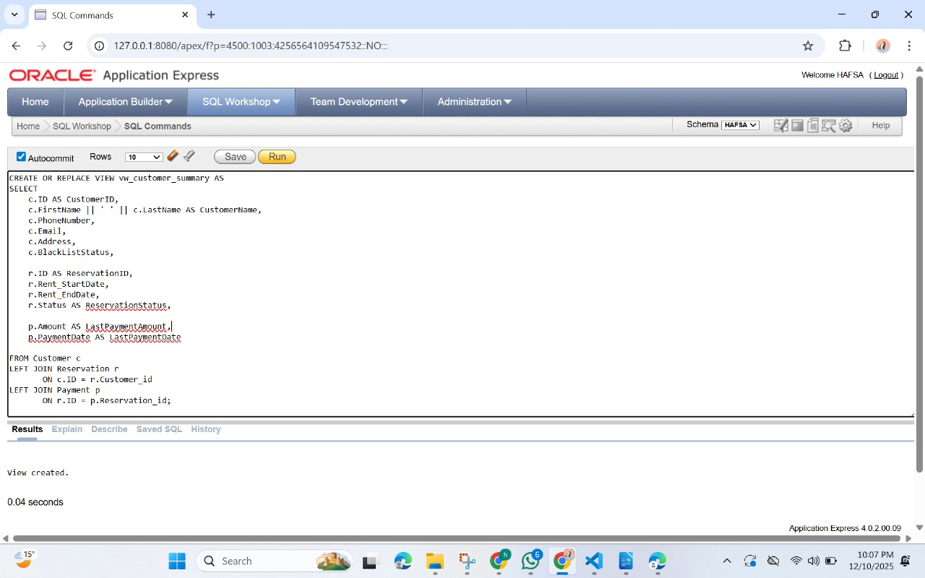

View: Vehicle Damage & Maintenance

CREATE OR REPLACE VIEW vw_vehicle_damage_maintenance AS SELECT d.Vehicle_id,

d.SeverityLevel,

d.Description AS DamageDetails,

d.EstimatedCost,

m.MaintenanceDate,

m.Cost AS MaintenanceCost

FROM Damage_Report d

LEFT JOIN Maintenance m ON d.Vehicle_id = m.Vehicle_id;

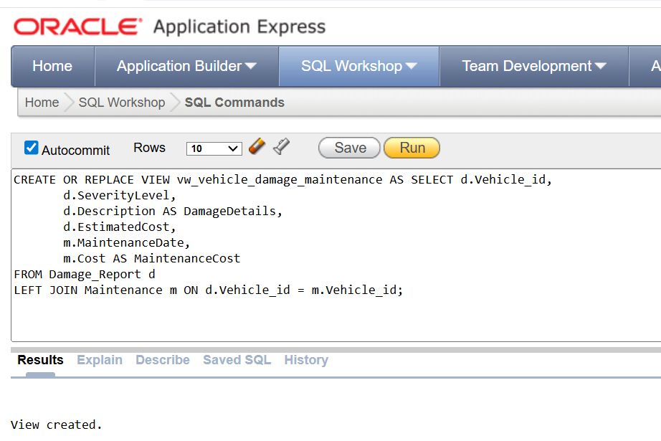

COMPLEX SQL QUEIES

1. **Which vehicles cost more in maintenance than they earned in rental revenue (loss-making vehicles).**

SQL Query

SELECT v.ID, v.Color, (SELECT NVL(SUM(m.Cost),0) FROM Maintenance m WHERE m.Vehicle_id = v.ID) AS MaintenanceCost, (SELECT NVL(SUM(p.Amount),0) FROM Reservation r JOIN Payment p ON r.ID = p.Reservation_id WHERE r.Vehicle_id = v.ID) AS RentalRevenue FROM Vehicle v WHERE (SELECT NVL(SUM(m.Cost),0) FROM Maintenance m WHERE m.Vehicle_id = v.ID) > (SELECT NVL(SUM(p.Amount),0) FROM Reservation r JOIN Payment p ON r.ID = p.Reservation_id WHERE r.Vehicle_id = v.ID)

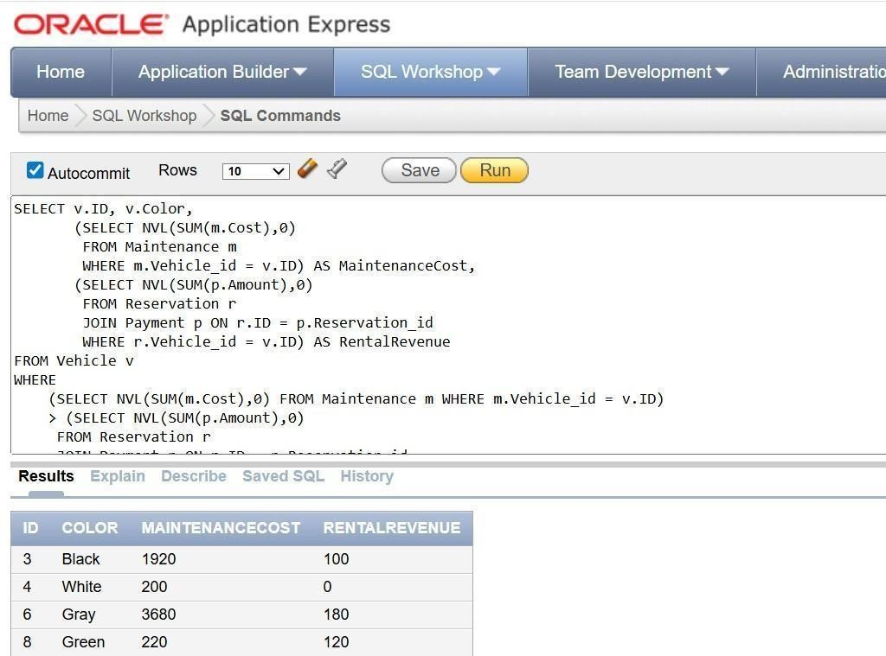

**2.Which vehicles generated the highest rental revenue from fully paid reservations**.

**SQL Query**

SELECT v.ID, v.Color, SUM(p.Amount) AS Revenue FROM Vehicle v JOIN Reservation r ON v.ID = r.Vehicle_id JOIN Payment p ON r.ID = p.Reservation_id WHERE r.PaymentStatus = 'PAID' GROUP BY v.ID, v.Color HAVING SUM(p.Amount) = ( SELECT MAX(TotalRev) FROM ( SELECT SUM(p2.Amount) AS TotalRev FROM Reservation r2 JOIN Payment p2 ON r2.ID = p2.Reservation_id GROUP BY r2.Vehicle_id ) )

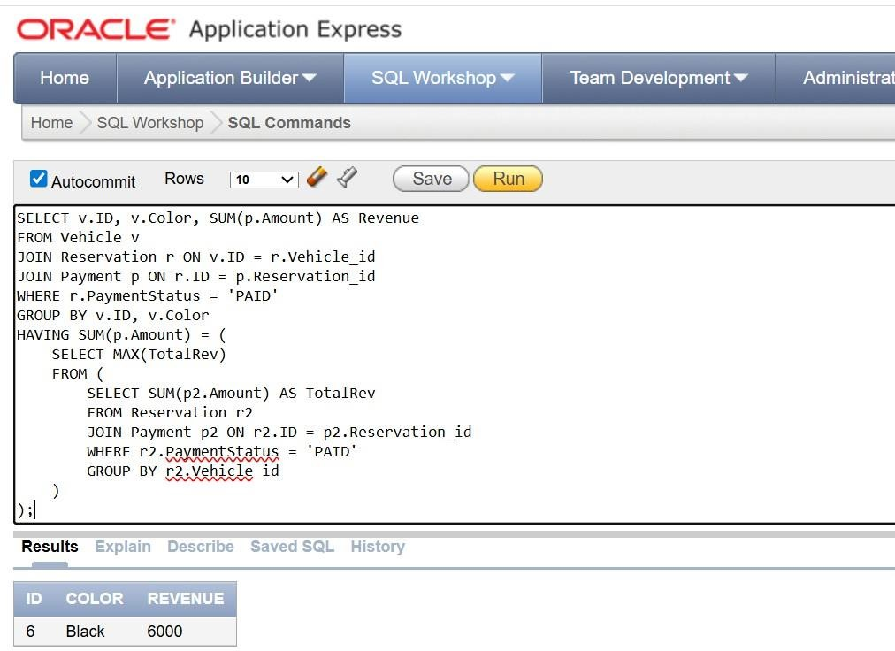

3.**Which staff members handled more reservations than the average staff workload**

**SQL QUERY**

SELECT s.ID, s.FirstName, COUNT(r.ID) AS TotalReservations FROM Staff s JOIN Reservation r ON s.ID = r.Staff_id GROUP BY s.ID, s.FirstName HAVING COUNT(r.ID) > (SELECT AVG(Count(*)) FROM RESERVATION GROUP BY Staff_id )

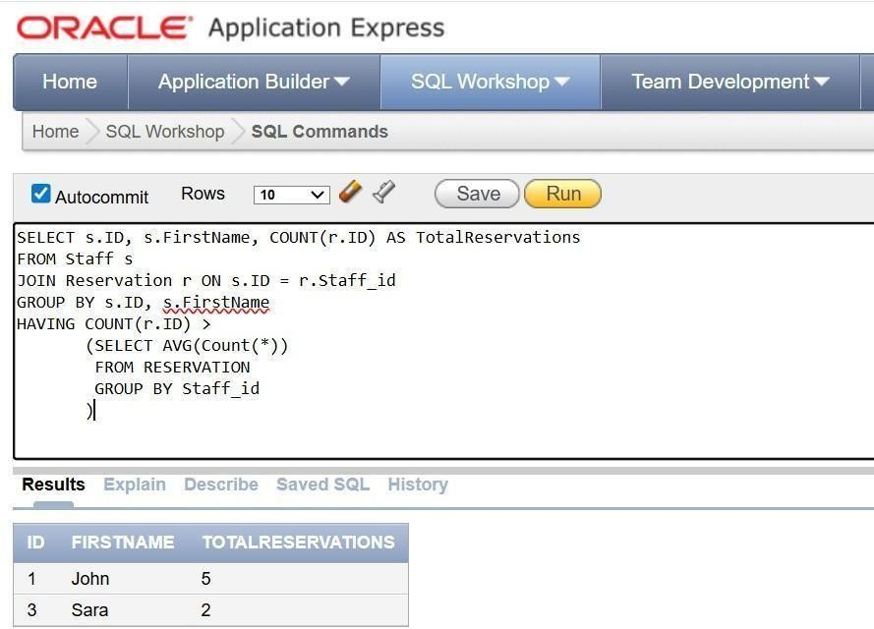

4. **Which customers rented vehicles that were later reported as damaged.**

**SQL QUERY**

SELECT DISTINCT c.ID, c.FirstName, c.LastName FROM Customer c JOIN Reservation r ON c.ID = r.Customer_id JOIN Damage_Report d ON r.ID = d.Reservation_id

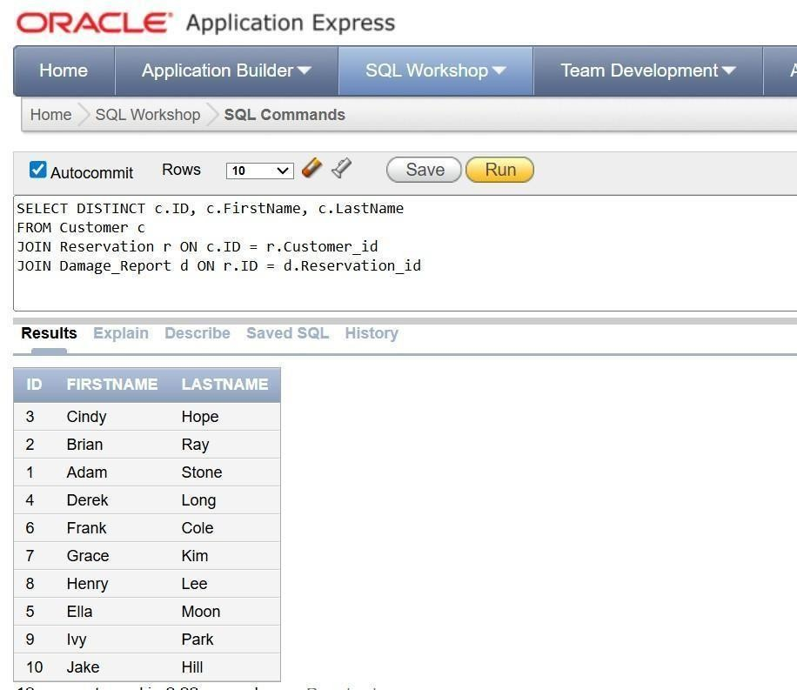

5. **. Which vehicles are currently reserved but have no recorded payments.**

**SQL Query**

SELECT v.ID, v.Color FROM Vehicle v JOIN Reservation r ON v.ID = r.Vehicle_id WHERE r.PaymentStatus = 'UNPAID' AND r.ID NOT IN ( SELECT Reservation_id FROM Payment )

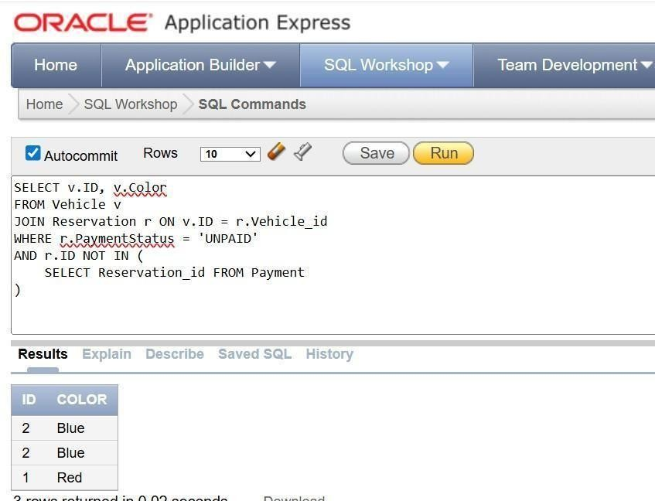

6Show All Blacklisted Customers & Their Reservation History

SQL Query:

SELECT c.ID AS CustomerID, c.FirstName || ' ' || c.LastName AS CustomerName, c.Email, r.ID AS ReservationID, r.Status, r.PaymentStatus FROM Customer c LEFT JOIN Reservation r ON r.Customer_id = c.ID WHERE c.BlackListStatus = 'Y' ORDER BY c.ID;

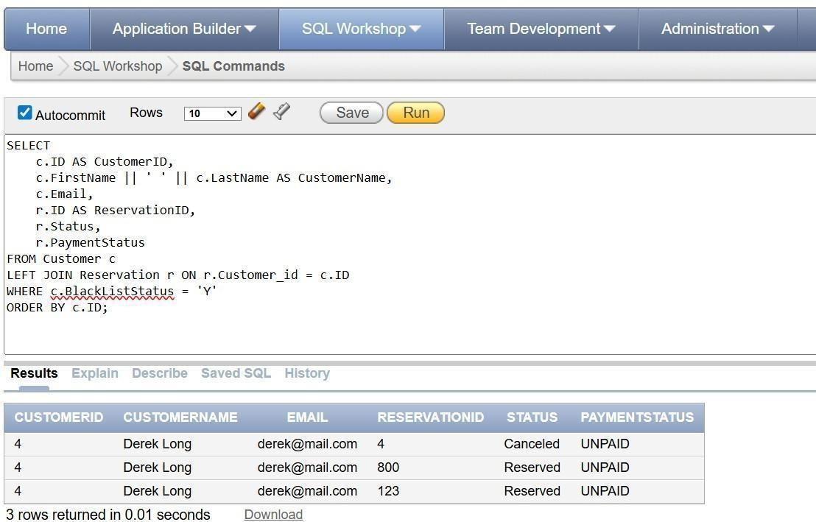

7. List All Active Reservations With Customer, Vehicle, Company & Payment Info.

SQL Query:

SELECT r.ID AS ReservationID, c.FirstName || ' ' || c.LastName AS CustomerName, v.ID AS VehicleID, comp.Name AS CompanyName, r.Rent_StartDate, r.Rent_EndDate, NVL(SUM(p.Amount), 0) AS TotalPaid, r.PaymentStatus FROM Reservation r JOIN Customer c ON r.Customer_id = c.ID JOIN Vehicle v ON r.Vehicle_id = v.ID JOIN Company comp ON v.Company_id = comp.ID LEFT JOIN Payment p ON p.Reservation_id = r.ID WHERE r.Status = 'Reserved' GROUP BY r.ID, c.FirstName, c.LastName, v.ID, comp.Name, r.Rent_StartDate, r.Rent_EndDate, r.PaymentStatus;

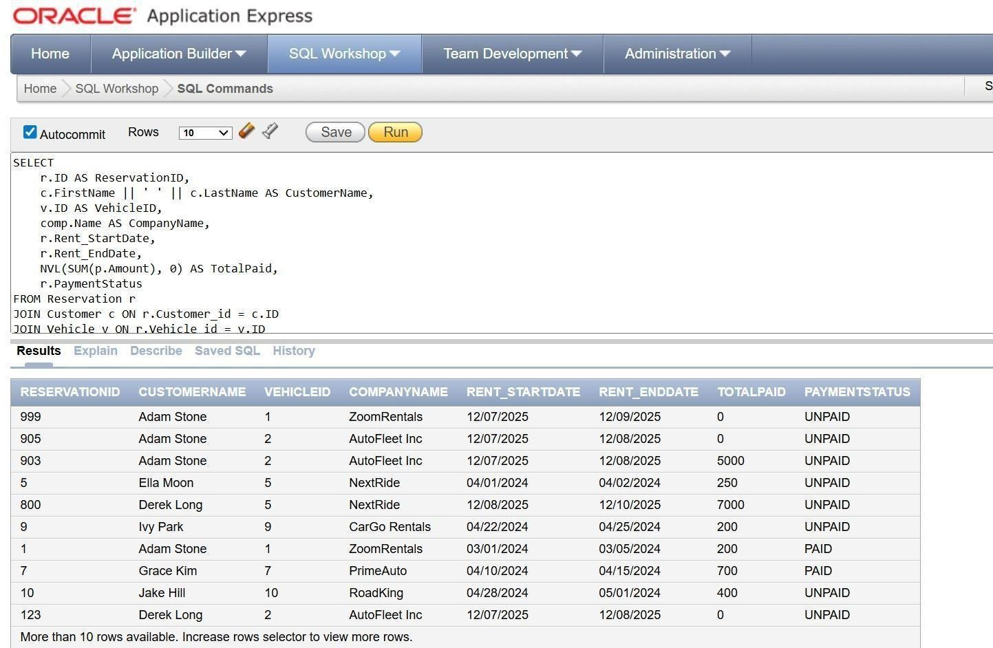

8.

9.

10.

8.List Vehicles With Highest Maintenance Cost:

SQL Query

SELECT v.ID AS VehicleID, pn.PlateNumber, SUM(m.Cost) AS TotalMaintenanceCost FROM Vehicle v JOIN Maintenance m ON m.Vehicle_id = v.ID JOIN PlateNumber pn ON pn.Vehicle_id = v.ID GROUP BY v.ID, pn.PlateNumber ORDER BY TotalMaintenanceCost DESC;

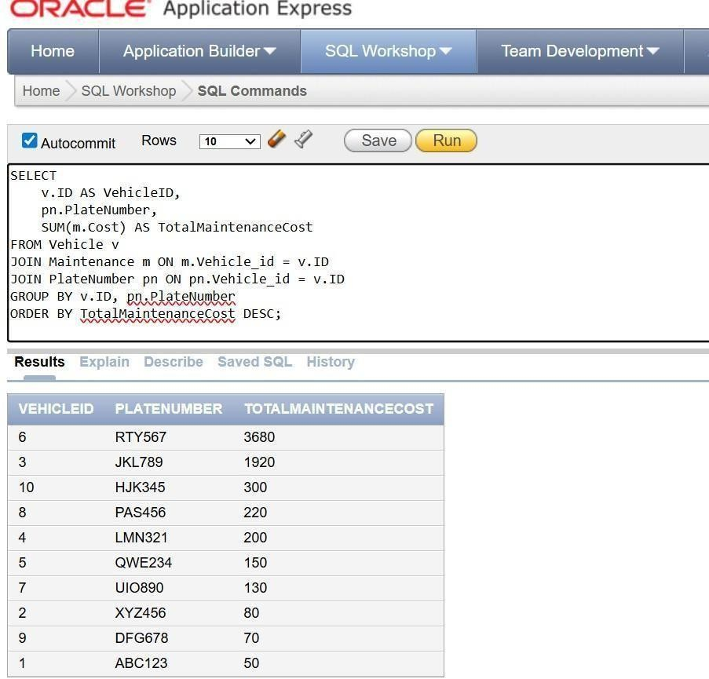

9. Which vehicles have never been reserved by any customer

SQL Query

SELECT v.ID, v.Color FROM Vehicle v WHERE v.ID NOT IN ( SELECT DISTINCT Vehicle_id FROM Reservation )

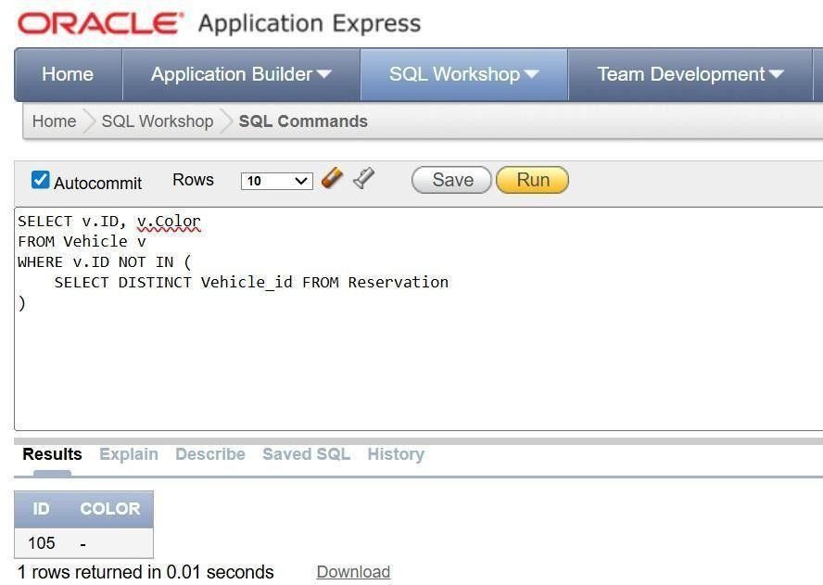

9. Which vehicles required maintenance because of HIGH severity damage . SQL Query SELECT v.ID, v.Color, d.SeverityLevel, m.Description AS MaintenanceReason FROM Vehicle v JOIN Damage_Report d ON v.ID = d.Vehicle_id JOIN Maintenance m ON v.ID = m.Vehicle_id WHERE d.SeverityLevel = 'HIGH'

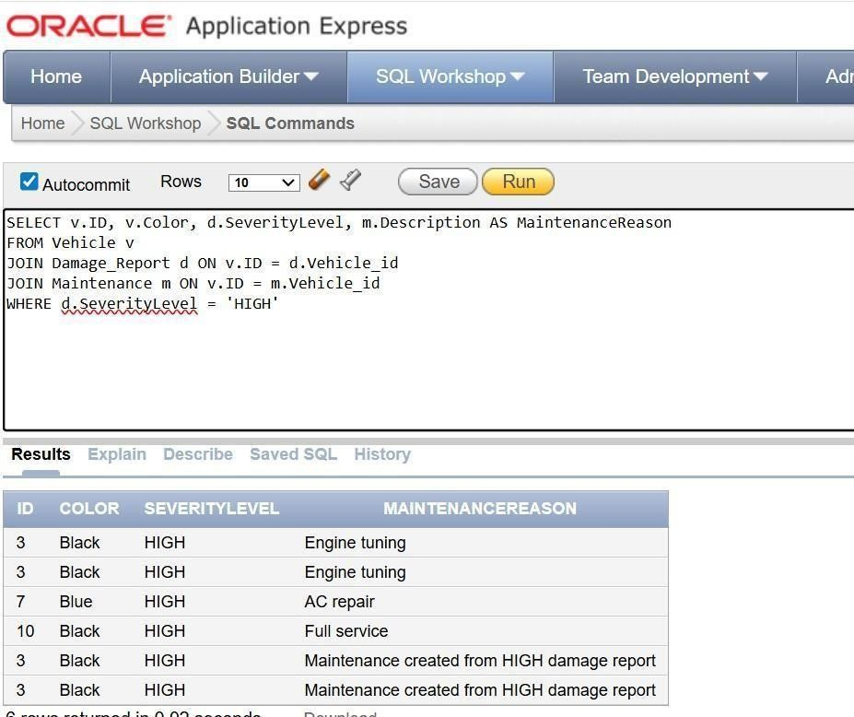

10.

Testing And Error Handling: →UPDATE Reservation SET Status = 'Canceled' WHERE ID = 11; Expected: Test 1: Vehicle Status Returns to Active When Reservation is Canceled: →SELECT Status FROM Vehicle WHERE ID = 1; Vehicle status → Active

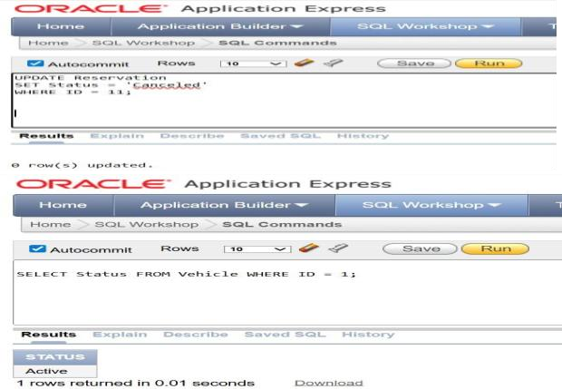

Test 2: Insert Customer With Duplicate Email: (Customer emails must be UNIQUE) The email ‘adam@mail.com’ already exists,so an error should be generated. →INSERT INTO Customer (ID, FirstName, LastName, PhoneNumber, Email, Address, BlackListStatus) VALUES (101, 'Ali', 'Raza', '0300000000', 'adam@mail.com', 'Lahore', 'N');

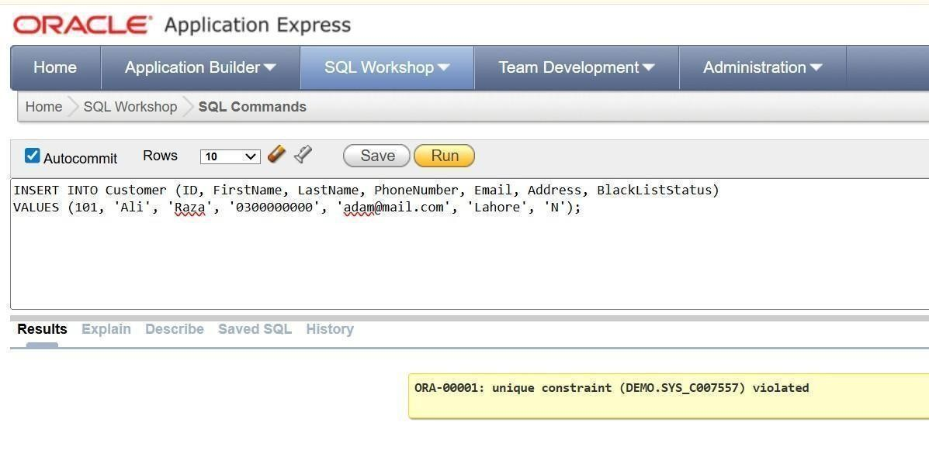

Test 3: Staff Id not existed in the Maintenance table (When we try to add maintenance data for a vehicle against a staff_id who doesn’t exist) Expected: Integrity Constraint violation!!!!!

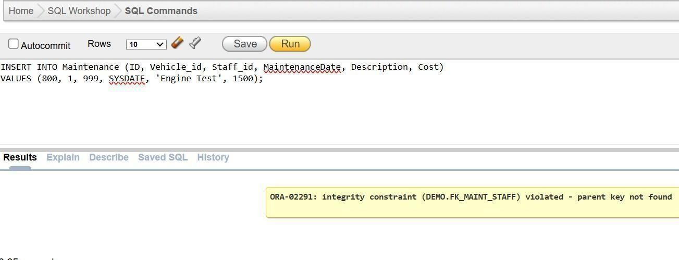

Test 4: Vehicle Status Automatically Changes to RESERVED INSERT Reservation → Vehicle.Status must become ‘Reserved’ *INSERT INTO Reservation (ID, Customer_id, Vehicle_id, Staff_id, DriverRequired, Rent_StartDate, Rent_EndDate, Status, PaymentStatus) VALUES (903, 1, 2, 1, 'N', SYSDATE, SYSDATE+1, 'Reserved', 'UNPAID'); *SELECT Status FROM Vehicle WHERE ID = 2;

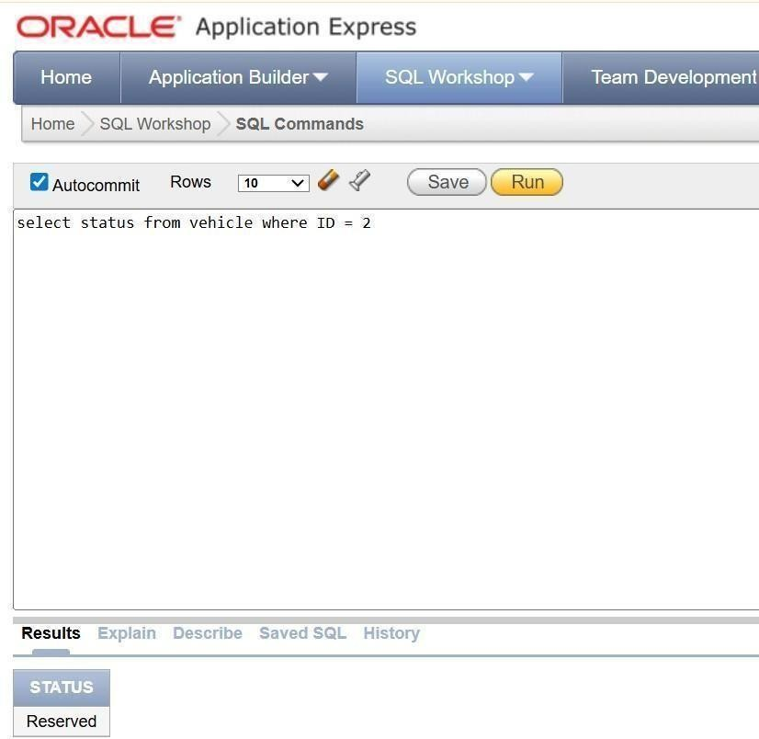

Test 5: Is the vehicle available or not: Check the availability of vehicle BEGIN Add_Reservation_Safely( ); END; / 101, 4, 1, 1, 'N', DATE '2024-05-10', DATE '2024-05-12', 200 Expected ERROR: ORA-20010: Vehicle is not available for reservation

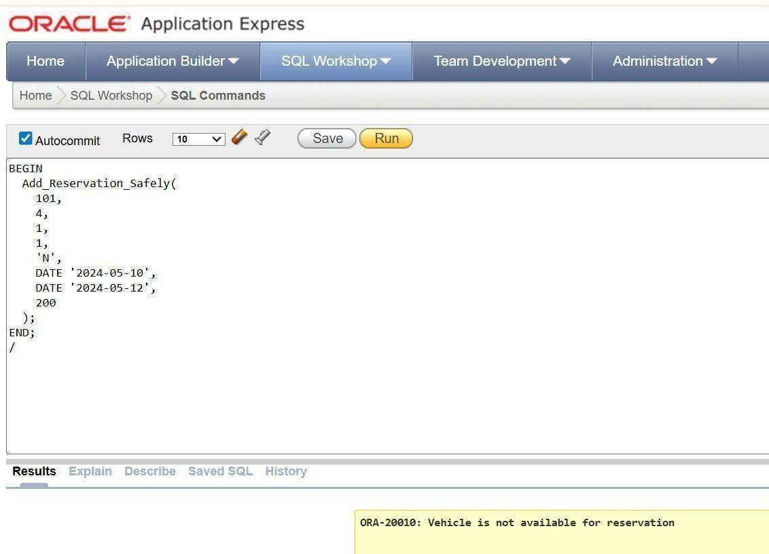

Test 6: Blacklist Customer cannot reserve a vehicle UPDATE Customer SET BlackListStatus = 'Y' WHERE ID = 10; (ID, Customer_id, Vehicle_id, Staff_id, DriverRequired, Rent_StartDate, Rent_EndDate, Status, PaymentStatus) VALUES (501, 10, 3, 2, 'N', SYSDATE, SYSDATE + 2, 'Reserved', 'UNPAID'); Expected error: This customer is blacklisted and cannot make a reservation.

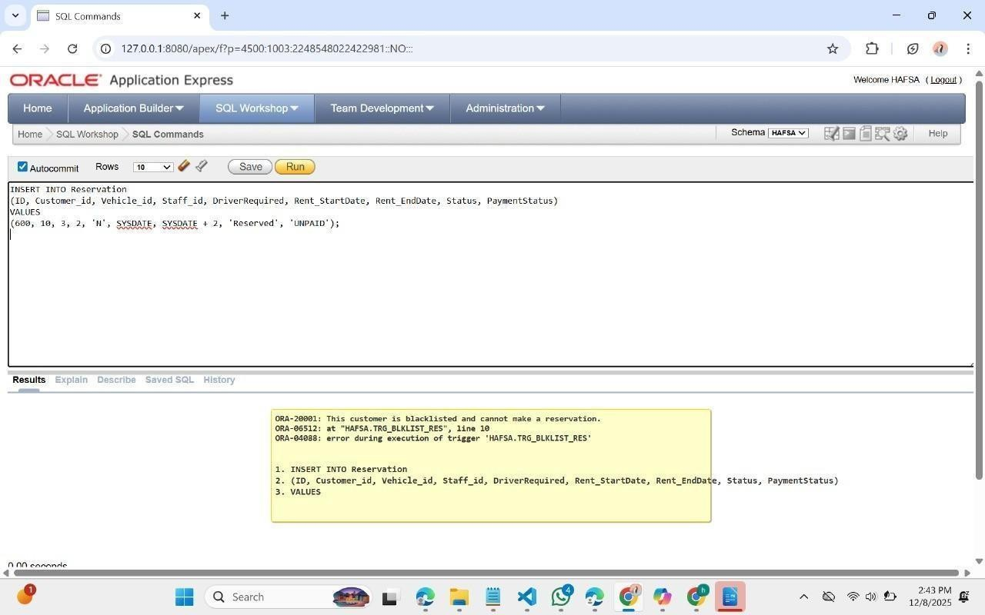

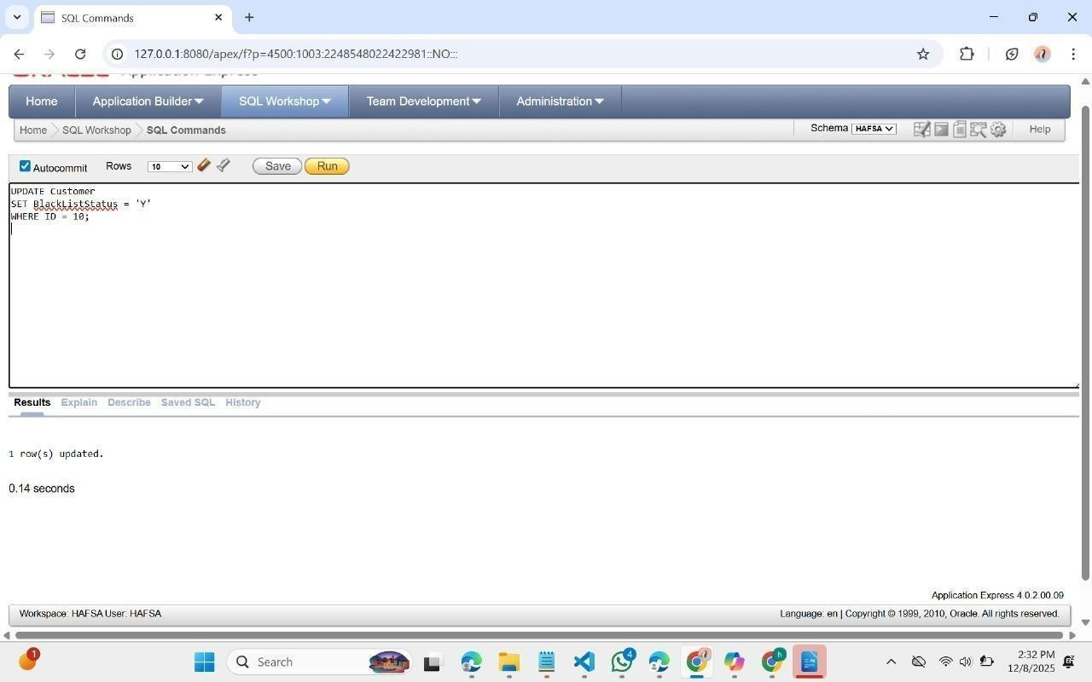

Test 7: No overlapping reservations (Reservations cannot overlap for the same vehicle) Expected Error : This vehicle already has an active reservation in this date range. INSERT INTO Reservation (ID, Customer_id, Vehicle_id, Staff_id, DriverRequired, Rent_StartDate, Rent_EndDate, Status, PaymentStatus) VALUES (600, 2, 1, 1, 'N', DATE '2025-01-10', DATE '2025-01-15', 'Reserved', 'UNPAID'); ….. INSERT INTO Reservation (ID, Customer_id, Vehicle_id, Staff_id, DriverRequired, Rent_StartDate, Rent_EndDate, Status, PaymentStatus) VALUES (601, 3, 1, 1, 'N', DATE '2025-01-12', DATE '2025-01-18', 'Reserved', 'UNPAID');

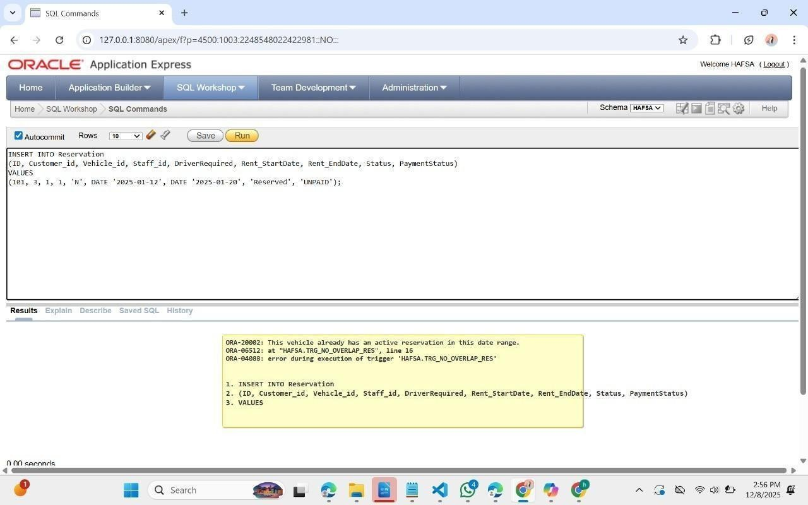

: Prevent Maintenance while vehicle is reserved UPDATE Vehicle SET Status = 'Reserved' WHERE ID = 3; INSERT INTO Maintenance (ID, Vehicle_id, Staff_id, MaintenanceDate, Description, Cost) VALUES (900, 3, 8, SYSDATE, 'Engine Tuning', 5000); Expected Error: Cannot insert maintenance: Vehicle is Reserved or Rented.

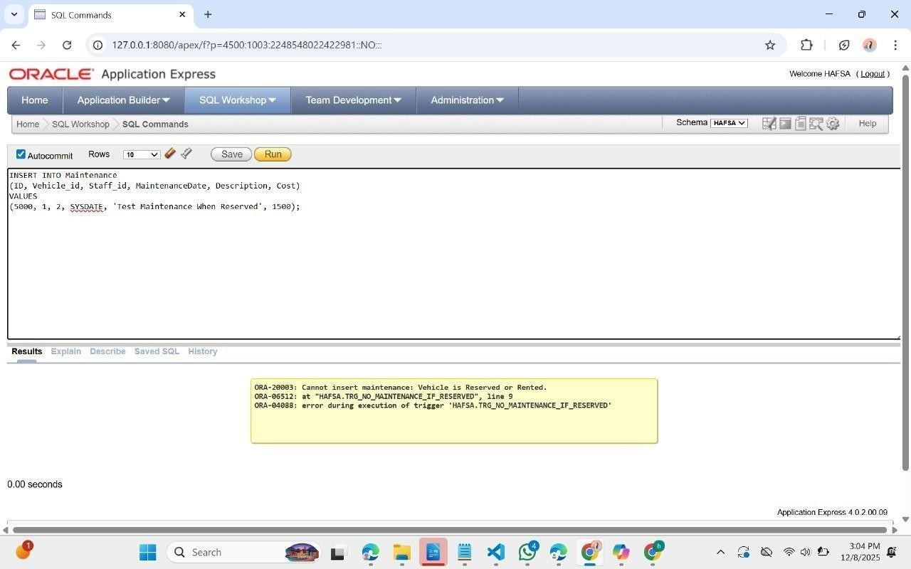

st 9: Only Mechanics Can Do Maintenance -- Suppose staff ID 5 is DRIVER role INSERT INTO Maintenance (ID, Vehicle_id, Staff_id, MaintenanceDate, Description, Cost) VALUES (901, 2, 5, SYSDATE, 'Oil Change', 2000); Expected error: Only mechanics (Other Staff role) can perform maintenance.

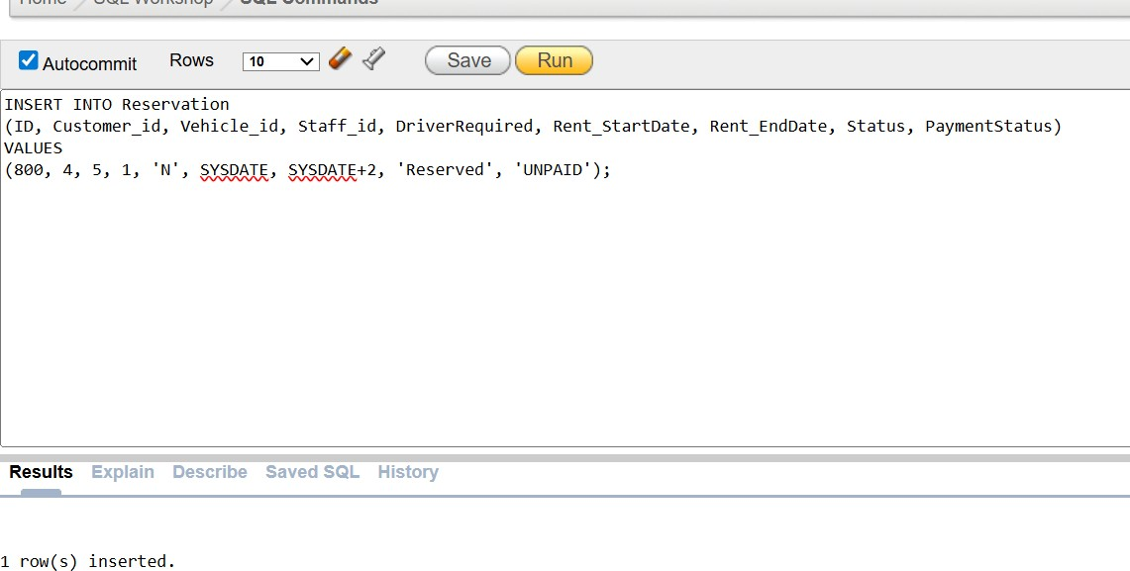

FINAL

PROFESSIONAL

TOUCH

Positive

Test

Cases

System

(

Should

Allow

These)

**Test**

**A:**

Successful

New

Reservation

INSERT INTO Reservation

(

ID,

Customer_id,

Vehicle_id,

Staff_id,

DriverRequired,

Rent_StartDate,

Rent_EndDate,

Status, PaymentStatus)

VALUES

,

(800

4

,

5

,

1

,

'N',

SYSDATE,

SYSDATE+2,

'Reserved',

'UNPAID');

**Expected**

**Result:**

Reservation inserted successfully

Vehicle

5

→

Status

becomes

Reserved

